Akili Hsu
CDU S365178@students.cdu.edu.au
Produce documentation.

Contents
Introduction 2
Html original code: 2
Explanation: 3
<head>: 3
<body>: 4
<header>: 4
<footer>: 6
CSS: 7
CSS original code: 7
Explanation: 10

Introduction
HTML, which stands for Hypertext Markup Language, is the standard markup language used to create and design web pages. It provides the structure and framework for content on the World Wide Web, allowing developers to define the layout, format text, embed multimedia, and link to other web pages and resources.
This guide would assist developers in inserting or updating any content on https://s365178.brambling.cdu.edu.au/WEBDEV1/ICT431/TASK2/layout.html.

Html original code:
<!DOCTYPE html>
<html lang="en">

<head>
<meta charset="UTF-8">
<meta name="viewport" content="width=device-width, initial-scale=1.0">
<title>Akili's Web</title>
<link rel="stylesheet" href="CSS/style.css">
</head>

<body>
<!-- header contains a logo and nav bars. -->
<header class="item">

<div id="logo">LOGO</div>
<div id="nav">
<button>Home</button>
<button>Services</button>
<button>About us</button>
<button>Contant</button>

</div>
</header>

<!-- The main area would be chopped into 4 pieces.
Boxes on the left would stretch according to the size of browser. The right boxes are fixes width.-->

<aside class="item" id="topleft">Left aside, might be empty</aside>
<aside class="item" id="topright">Right aside, might be empty</aside>
<main class="item" id="main">The main area, where content will be placed</main>
<aside class="item" id="buttomright">Right aside, might be empty</aside>

<footer class="item">Footer</footer>
</body>

</html>

Explanation:

<head>:
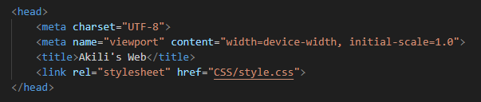
Contains the basic information of this website.
<meta charset="UTF-8">: Specifies the character encoding for the document as UTF-8, which supports a wide range of characters from different languages and ensures proper text display.
<meta name="viewport" content="width=device-width, initial-scale=1.0">: Defines the viewport settings for responsive web design. It sets the width of the viewport to the width of the device and ensures that the initial zoom level is set to 1.0, allowing the webpage to adapt its layout and scale properly on various devices and screen sizes.

<title>:
<title>Akili's Web</title>: Sets the title of the webpage, which appears in the browser's title bar or tab. In this case, the title is "Akili's Web".

<link rel="stylesheet" href="CSS/style.css">:
Links an external stylesheet named "style.css" located in a folder named "CSS" to the HTML document. This stylesheet contains CSS rules that define the presentation and styling of the webpage's content.
If the content contains images, we can create another folder name” image” and “link” the folder in heading section.

<body>:
This area contains everything for display, including header, main area and footer.
- The page must be responsive to the width of the window.

<header>:
This section contains the header of the web page, which includes elements like a logo and navigation bars. This is a semantic elements that describe the type of content they contain.
- This area must be greater than 125px high and less than 300px.
- You must include a navigation structure using a list to: Services, About Us, Contact, Home.
- The Main Page (left) area must be responsive with the width of the window.
- The background of the middle section must be grey (like in the image).
- The main body areas, both left and right must have a white background.
- The purple areas are invisible containers for where the text will appear.
As the client’s instruction, the main area would chopped into 4 pieces.
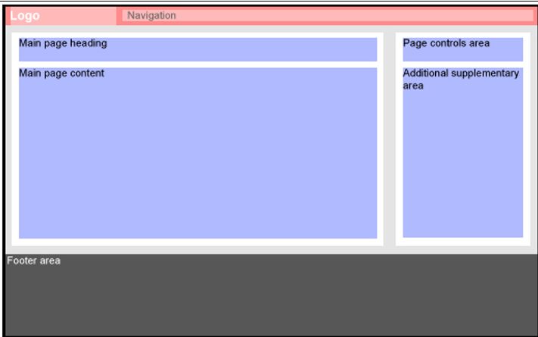
- Boxes on the left would stretch according to the size of browser.
- The right boxes are fixes width

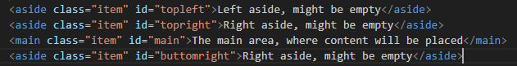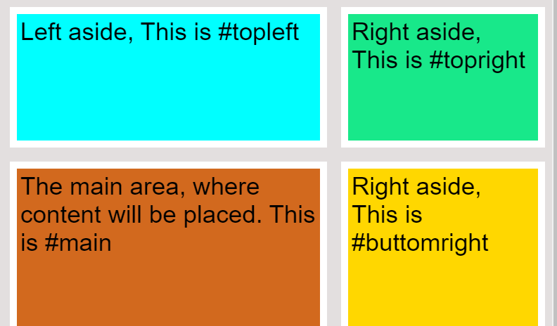
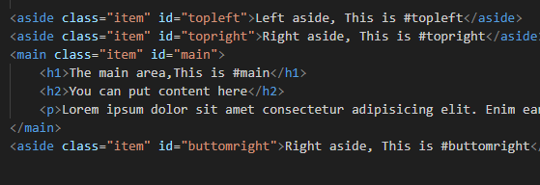
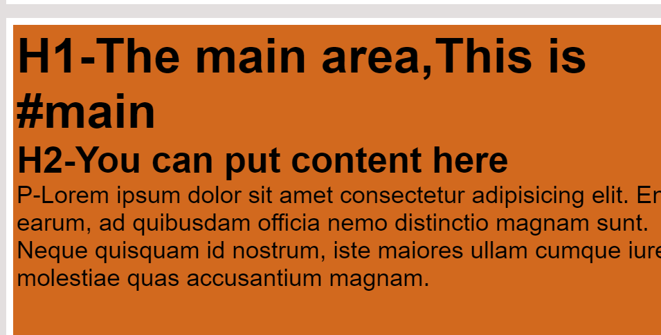
Main content area(#main)
- Numeric day of the month
- Month
- Article title
- Article date
- Article author (with email hyperlink)
- The first paragraph of the article content
- A ‘read more…’ link

<footer>:
This is a semantic elements that describe the type of content they contain.
- The footer area is responsive to the browser width.
- The area is dark grey and 300px high.

CSS:

CSS original code:
*{
margin: 0;
padding: 0;
box-sizing: border-box;
}
body{
/* Chopped the page into a 3 column* 4 rows */
display: grid;
grid-template-columns: 1fr 2fr 300px;
grid-template-rows: auto 200px 2fr 1fr;
min-height: 80vh;
gap: 20px;
background-color: rgba(221, 216, 216, 0.829);
}
header{
background-color: rgb(230, 190, 200);
grid-column: 1/4;
height: 130px;
display: flex;
/* Make the logo sit next to nav bar */
align-items: center;

}

#topleft{
background-color: aqua;
grid-column: 1/3;
margin-left: 20px;
}
#topright{
background: rgb(24, 232, 138);
grid-column: 3/4;
margin-right: 10px;
}
#main{
background-color: chocolate;
grid-column: 1/3;
margin-left: 20px;
}
#buttomright{
margin-right: 10px;
background: gold;
grid-column: 3/4;

}
footer{
font-size: 35px;
background-color: rgb(168, 172, 168);
grid-column: 1/4;
height: 300px;
}

#topleft, #topright, #main, #buttomright{
padding: 5px;
font-size: 35px;
font-family: Arial, Helvetica, sans-serif;
border: 10px solid;
border-color: white;
}

#logo{
text-align: left;
font-size: 50px;
margin-right: 10%;
margin-left: 20px;
}

#nav{
border: 6px solid;
width: 100%;
padding: 25px;
border-color: red ;
}
button{
font-size: larger;
padding: 20px;
border-radius: 20px;
}

Explanation:
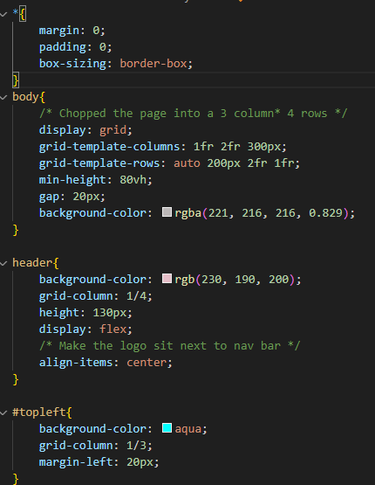
*{} select all
# target id
. target class

